STUDYING OF PRODUCT DIGITAL THERMOMETER
  - Introduction
A digital thermometer is an electronic device used to measure temperature using electronic sensors. It provides fast, accurate, and safe temperature readings and is widely used in medical, industrial, laboratory, and domestic applications.

  - Principle of Operation
Digital thermometers operate on the principle that certain electrical properties change with temperature. A temperature sensor detects this change and converts it into an electrical signal, which is processed and displayed as a numerical value. 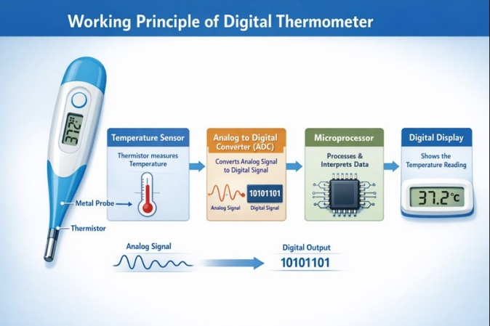

  - Main Components
1. Temperature Sensor
2. Analog-to-Digital Converter (ADC)
3. Microcontroller
4. Display Unit (LCD/LED)
5. Power Supply (Battery)
6. Control Buttons

  - Diagram – External View
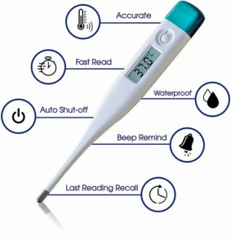
[Insert Image of Digital Thermometer External View Here]
Shows probe tip, display, and control button.
Diagram – Block Diagram
[Insert Block Diagram Image Here]
Sensor → ADC → Microcontroller → Display
  - Working
1. Thermometer is switched ON
2. Sensor detects temperature
3. Signal is converted to digital form
4. Microcontroller processes data
5. Temperature is displayed
  - Types
1. Medical Digital Thermometer
2. Infrared Thermometer
3. Industrial Thermometer
4. Laboratory Thermometer
  - Advantages
• Accurate
• Fast response
• Safe (No mercury)
• Easy to use
  - Disadvantages
• Requires battery
• Electronic failure possible
  - Applications
• Medical diagnosis
• Industry
• Food safety
• Laboratories
BY
S.MASTHAN SHERIF KAN B.E (BIO-MEDICAL)

